Lesson 4 Demo 5: Publishing Ports

This section will guide you to:

* Publish a swarm service’s port to external hosts in different ways

**Step 1:** Publish a swarm service’s port using the Routing Mesh

**Note:** If Docker Swarm is not initialized on the **master** node, initialize docker swarm

*sudo docker swarm init*

* Use *--publish <PUBLISHED-PORT>:<SERVICE-PORT>* to publish a port externally to the swarm:

*sudo docker service create --name service1 *

*--replicas 3 --publish published=8080,target=80 nginx*

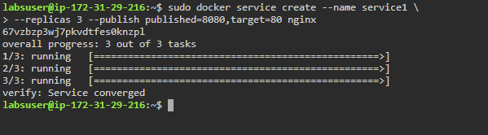

**Note:** You can also write the above command it this way:

*docker service create --name service1 --replicas 3 -p 8080:80 nginx*

* Use the following command to check whether your service has started on port 8080:

*curl localhost:8080*

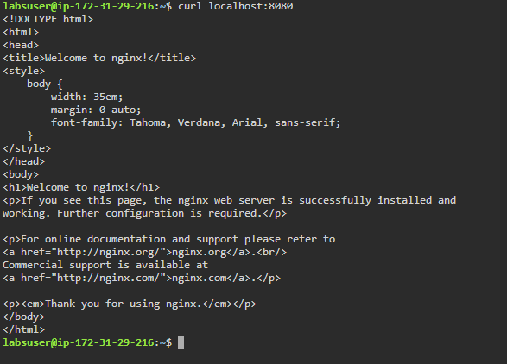

**Step 2:** Publish a swarm service’s port directly on the swarm node

* Use the *mode=host* option with *--publish* flag along with *--mode global* flag to publish a port directly on the swarm node

*sudo docker service create --mode global *

*--publish mode=host,target=80,published=8081 *

*--name=service2 nginx:latest*

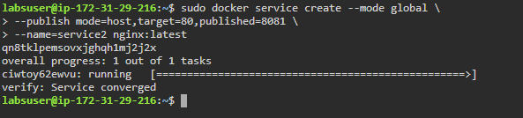

* Use the following command to check whether your service has started on port 8081:

*curl localhost:8081*

